HONORS CHEMISTRY • UNIT 0
Measurement & Math Skills
Every number in chemistry comes from a measurement. Learn to take them, write them, and work with them honestly.

TEACHER EDITION
Everything in a light-gray box or cell is an answer or model response. Teacher notes (misconceptions, demo ideas, discussion prompts, sources) appear in the heavy-bordered boxes labeled TEACHER NOTE. The pages follow the student packet, so they line up closely.

What we will learn
0.1 | Making accurate measurements
0.2 | Significant figures & scientific notation
0.3 | Calculations with significant figures
0.4 | Dimensional analysis (unit conversions)
0.5 | Density
★ | Extra practice, error analysis & unit review

By the end of this unit I can…
• Choose the right piece of lab equipment and read a scale to the correct decimal place.
• Tell accuracy from precision and use percent error.
• Count significant figures and round correctly; write numbers in scientific notation.
• Add, subtract, multiply and divide measurements and report the right number of sig figs.
• Convert between units with multi-step dimensional analysis (including squared and cubed units).
• Calculate density, mass or volume and identify a substance from its density.
• Design a simple lab procedure and explain where measurement error comes from.
Unit at a glance (teacher)
Topic | Suggested pacing | Depth the homework expects
0.1 Measurements | 1 day | Read cylinders/burets to the estimated digit; draw meniscus.
0.2 Sig figs & sci. notation | 1 day | Count sig figs (incl. 100., 0.0100, 500); round to 4/3/2 s.f.; sci. notation.
0.3 Calcs with sig figs | 1 day | Write calculator answer, then the rounded answer; add/sub vs mult/div.
0.4 Dimensional analysis | 1–2 days | Multi-step conversions (cm→in, yd→mi, mi/h→ft/min, $/oz→lb) with all work shown.
0.5 Density | 1–2 days | Conceptual (intensive property), regular solid, displacement, mass and volume from density.

TEACHER OVERVIEW
Big picture. This unit is the toolbox. Students who leave it able to (1) pick a tool, (2) read it to one estimated digit, and (3) carry that honesty through calculations will make fewer mistakes in stoichiometry, gas laws and thermochemistry.
Misconceptions to watch for:
• "More digits = more accurate." A calculator display is not a measurement.
• Treating trailing zeros as always (or never) significant. The decimal point decides.
• Rounding at every step (round only at the end; carry one extra digit).
• Believing that bigger objects have bigger density.
• Flipping conversion factors without checking that the units cancel.

IMAGES
Image spots: where a spot is marked "IMAGE GOES HERE", the homework packet or an AP exam figure (reading a buret/cylinder) works well. The scale drawings in this packet were made specifically so students can practise estimating the last digit.

TOPIC  0.1 | Making Accurate Measurements  Choosing tools • reading scales • accuracy vs precision

BIG IDEA
A measurement has two kinds of digits: the digits the tool lets you be certain about, and one estimated digit that you guess by eye. You always report all of them — and no more.

Key vocabulary — write each definition in your own words
Term | Definition (your words) | Example / sketch
Measurement | A quantity made with a tool that has a number AND a unit. It includes every certain digit plus one estimated digit. | 34.6 mL
Estimated digit | The last digit of a measurement. You guess it by eye between the smallest marks on the scale, so it is the uncertain digit. | In 34.6 mL the 6 is estimated.
Accuracy | How close a measurement is to the true (accepted) value. | A thermometer reads 100.1 °C in boiling water at sea level (true value 100 °C).
Precision | How close repeated measurements are to each other (how reproducible they are), whether or not they are correct. | Three masses: 9.52 g, 9.51 g, 9.53 g.
Meniscus | The curved surface of a liquid in a narrow tube. For water-based liquids you read the bottom of the curve with your eye level with it. | Sketch: U-shaped curve, edges climb the glass.

THINK OF IT LIKE… A CAR SPEEDOMETER
The speedometer has marks every 10 mph. If the needle sits a bit past 60, you would say "about 64." The 6 you were sure about; the 4 is your best estimate between the marks. A lab measurement works exactly the same way. Accuracy vs. precision: a basketball player who hits the same spot on the backboard every time (but never the hoop) is precise, not accurate.

How to read ANY scale (cylinder, buret, ruler, thermometer)
CUES / KEY WORDS  Step 1  Step 2  Step 3  Step 4 | WRITE THE FOUR STEPS IN YOUR OWN WORDS  1. Find the smallest mark on the scale and what it is worth (1 mL? 0.1 mL?).  2. Read the last mark the liquid/pointer has passed — these are your certain digits.  3. Estimate how far you are between marks by mentally cutting the gap into ten pieces — that is the one estimated digit.  4. Write certain digits + estimated digit with units. (If the liquid is exactly on a mark, the estimated digit is 0.)

TEACHER NOTE
Rule of thumb for students: you estimate one decimal place past the smallest marking. Some teachers allow ± one unit in the estimated digit when grading readings (e.g., 34.5–34.7 for reading A). Make that tolerance explicit up front.

LAB CORNER • Choosing the right tool

Chemists choose glassware based on how precisely they need to know a volume. Study the pieces below.
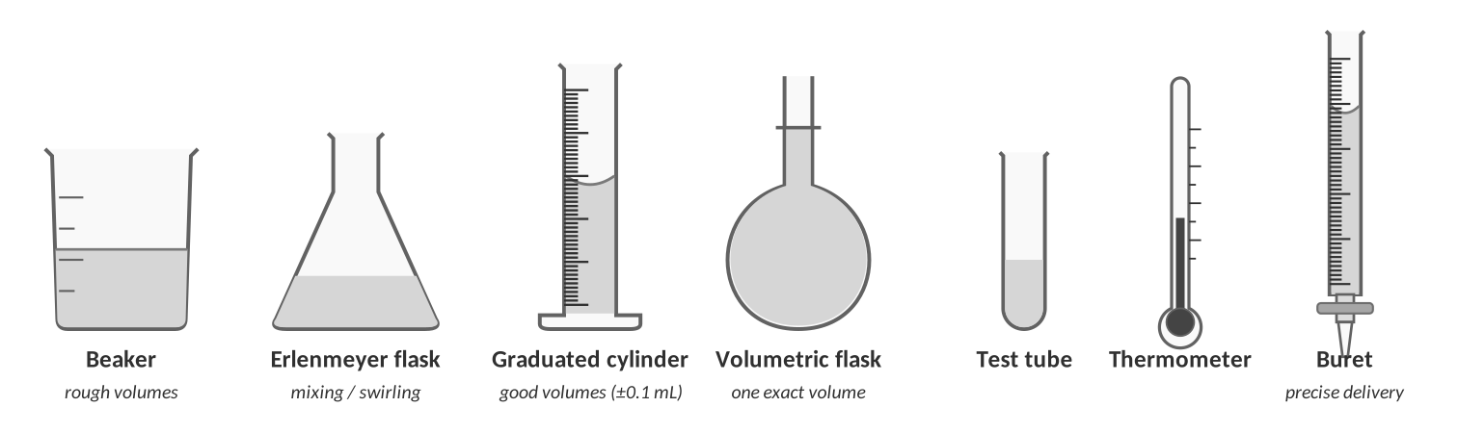
Common lab glassware and measuring tools (not to scale).
The job | Best tool | Why?
Deliver an exact, adjustable volume of acid drop by drop (titration) | Buret | Marked to 0.1 mL; stopcock lets you control the flow; read to ±0.01 mL.
Make exactly 250.00 mL of a solution with a known concentration | Volumetric flask | It holds one very exact volume when filled to the line.
Measure 37.4 mL of water for a reaction | Graduated cylinder | Marked to 1 mL (read to 0.1 mL); far better than a beaker.
Heat and stir roughly 100 mL of a solution | Beaker | Marks are only rough (±10%); good for holding, heating and mixing, not measuring.
Swirl a reaction mixture without splashing | Erlenmeyer flask | Narrow neck and sloping sides keep liquid in while you swirl.

LAB CORNER • Reading scales

Each drawing below is a zoomed-in piece of a real instrument. Read the bottom of the meniscus. Remember: certain digits + one estimated digit.
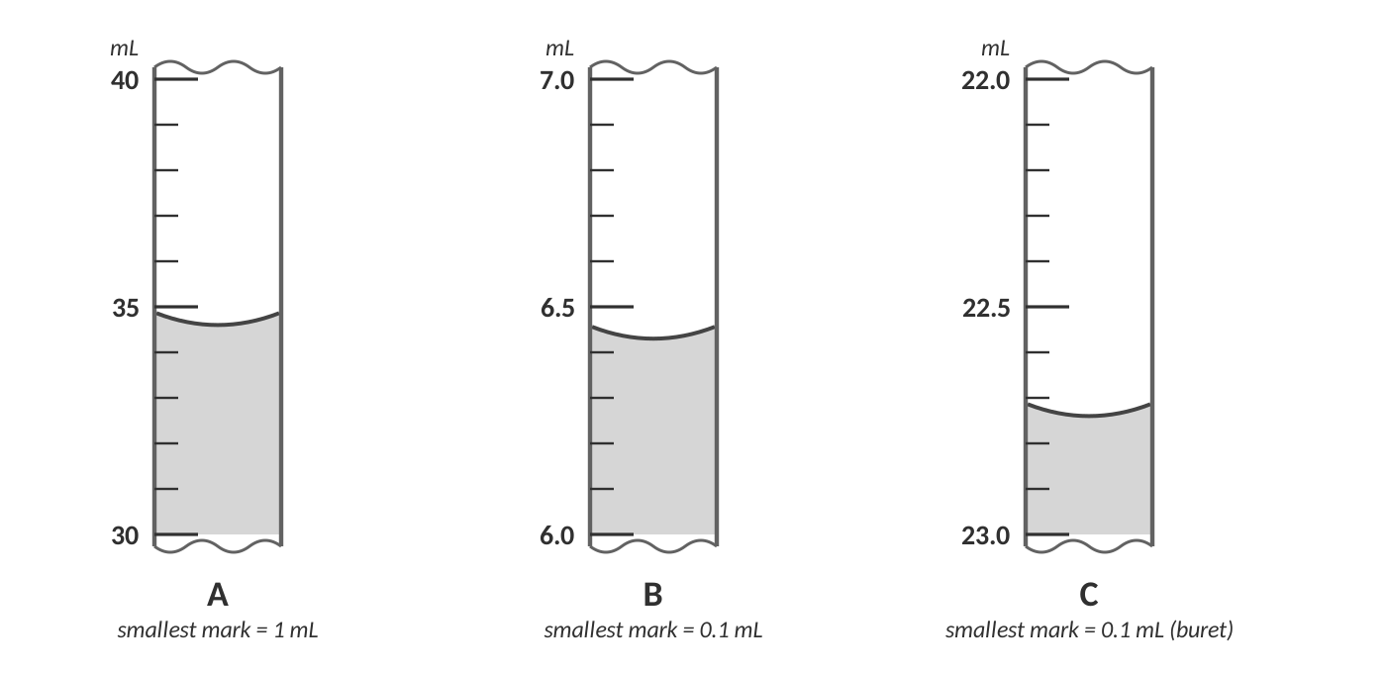
Scale readings A, B and C.
 | Smallest mark is worth | Reading (with unit) | Which digit is estimated? | # of sig figs
A | 1 mL | 34.6 mL | the 6 (tenths place) | 3
B | 0.1 mL | 6.43 mL | the 3 (hundredths place) | 3
C (buret) | 0.1 mL | 22.74 mL | the 4 (hundredths place) | 4

TEACHER NOTE
Accept A: 34.5–34.7; B: 6.42–6.44; C: 22.73–22.75. Buret scales run downward — the reading increases as liquid is delivered. Cylinder scales increase upward. This is a classic trap.

1. A classmate reads cylinder A as "35 mL" and another reads it as "34.60 mL." Explain what is wrong with each reading.
"35 mL" throws away the estimated digit — the tool can show the tenths place, so we should report 34.6 mL. "34.60 mL" claims a hundredths-place estimate, but the smallest marks are 1 mL, so the best we can honestly estimate is the tenths place.

2. Why does a buret reading to 22.74 mL have more significant figures than the cylinder reading of 34.6 mL? What does that tell you about the tool?
The buret has finer markings (0.1 mL vs. 1 mL), so its estimated digit is in the hundredths place instead of the tenths. A tool with smaller marks gives more precise measurements.

LAB CORNER • The meniscus and eye level

Water sticks to glass, so the liquid climbs the walls and forms a curve.
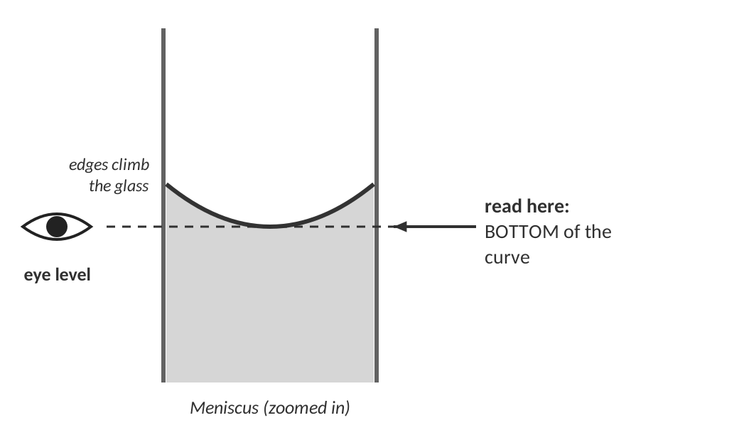
Always read at eye level, at the bottom of the curve.
3. Why does water form a meniscus that curves up at the walls?
Water molecules are attracted to the glass (adhesion) more strongly than they are to each other (cohesion), so the edges are pulled up the walls.

4. Draw a picture of what the meniscus would look like if you looked at the cylinder from slightly above the surface. Explain how this could make your reading wrong.
Looking from above (or below) the surface makes the meniscus line up with the wrong mark on the glass — a parallax error — so the reading is slightly high or low. Keep your eye level with the bottom of the curve.

EXTENSION
Mercury forms a convex (dome) meniscus because cohesion beats adhesion — a nice contrast for fast finishers. Quick demo: students read the same cylinder from three eye heights and compare.

LAB CORNER • Length with two different rulers

The same metal strip is measured with two rulers. Ruler 1 has marks every 1 cm; Ruler 2 has marks every 0.1 cm.
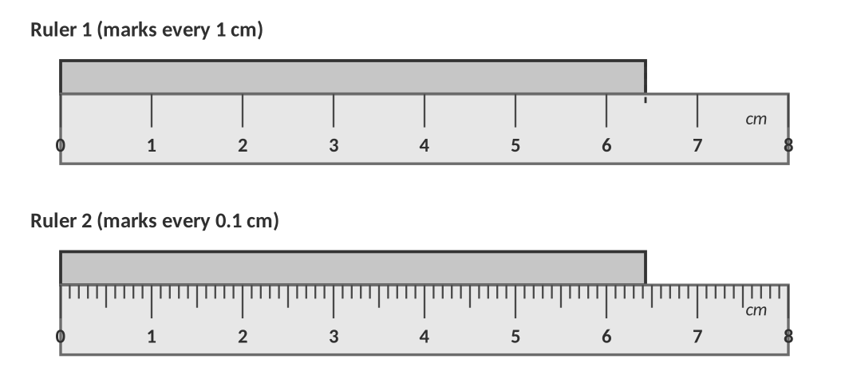
 | Smallest mark | Reading | Estimated digit
Ruler 1 | 1 cm | 6.4 cm | the 4 (tenths)
Ruler 2 | 0.1 cm | 6.43 cm | the 3 (hundredths)

5. Both readings are "correct." Why do they have different numbers of significant figures?
Ruler 2 has smaller marks, so it can show one more place of certainty. The number of sig figs always reflects the quality of the measuring tool.

[ IMAGE GOES HERE ]
Optional: photo or AP exam figure of a buret / graduated cylinder reading (homework Topic 0.1 figures)

LAB CORNER • Accuracy and precision

Four students throw darts at a target. The bullseye is the true value.
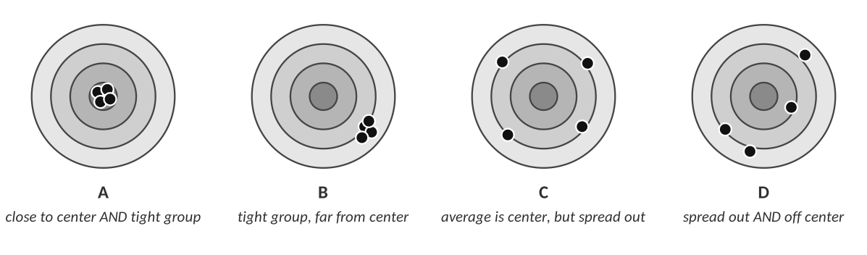
Target | Accurate? | Precise?
A | Yes | Yes
B | No | Yes
C | Yes (on average) | No
D | No | No

6. Three students each measure a 10.00 g standard mass three times.
a. Student 1: 10.01 g, 10.02 g, 10.00 g. Student 2: 9.52 g, 9.51 g, 9.53 g. Student 3: 9.2 g, 10.6 g, 10.0 g.
b. Describe the accuracy and precision of each student.
Student 1: accurate and precise. Student 2: precise but NOT accurate (a systematic error — maybe the balance was not zeroed). Student 3: accurate on average (the mean is 9.9 g) but not precise (large spread).

PERCENT ERROR
% error = |measured − accepted| ÷ accepted × 100
Use it to describe accuracy as a single number. Example: A student finds the density of iron to be 8.22 g/mL; the accepted value is 7.87 g/mL. % error = |8.22 − 7.87| ÷ 7.87 × 100 = 4.45 %

WATCH OUT!
Precision does not guarantee accuracy. A balance that is not zeroed gives beautifully precise wrong answers.

7. Quick check — which is a better description of a systematic error: a balance that always reads 0.30 g too high, or a student who sometimes reads the cylinder from above? Why?
The balance that is always 0.30 g high. A systematic error pushes every result the same direction (hurting accuracy), while inconsistent reading technique is a random error (hurting precision).

IDEA
Demo (5 min): have 4 groups each measure the mass of the same 5 g piece on different balances; plot the class results on the board and label accuracy and precision.

TOPIC  0.2 | Significant Figures & Scientific Notation  Which digits count • rounding • writing very large and small numbers

BIG IDEA
Significant figures (sig figs) tell the reader how well you know a number. Sig figs = all certain digits + the one estimated digit.

THINK OF IT LIKE… A PHOTO’S RESOLUTION
"I live somewhere in Tennessee" and "I live at 123 Main Street, Spring Hill" can both be true — but one has far more detail. A number with more sig figs is a sharper picture. If someone says "about 1500 people were at the game," the trailing zeros are placeholders (a rounded estimate). If an attendance scanner reports "1500." it counted every one. The decimal point is the signal.

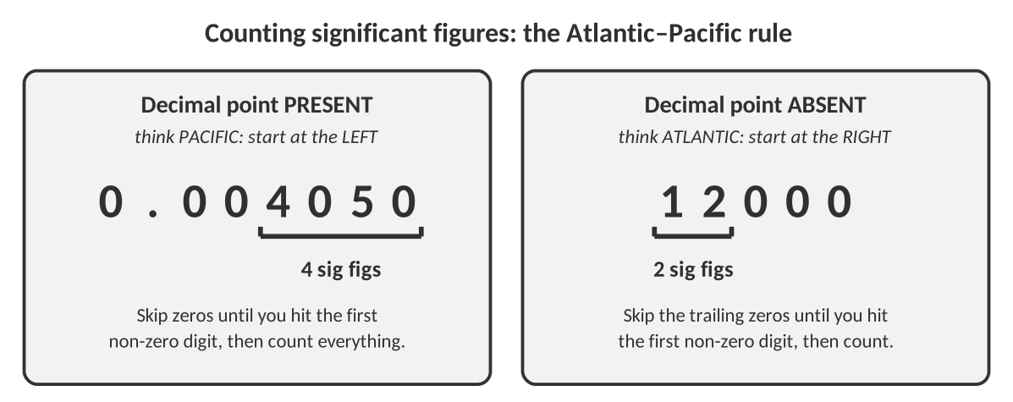
Build the rules — write each rule in your own words
Type of digit | The rule (your words) | Example | Sig figs
Non-zero digits | Every non-zero digit is significant. | 4.37 and 437 | 3 and 3
Captive zeros | Zeros between non-zero digits are significant. | 5004 and 1.002 | 4 and 4
Leading zeros | Zeros before the first non-zero digit are NEVER significant — they only show where the decimal is. | 0.0052 | 2
Trailing zeros WITH a decimal point | Zeros at the end of a number that has a decimal point ARE significant. | 25.00 and 100. | 4 and 3
Trailing zeros WITHOUT a decimal point | Zeros at the end of a number with no decimal point are NOT significant (they are placeholders). | 1500 and 90 | 2 and 1
Exact numbers | Counted numbers and definitions have unlimited sig figs and never limit your answer. | 24 students; 12 in = 1 ft | infinite

WATCH OUT!
Scientific notation removes the confusion. 1500 has 2 sig figs, but 1.500 × 10³ has 4. Every digit in the coefficient (the part before ×10) is significant.

Practice A — count the significant figures
Number | # sig figs | Number | # sig figs
4.056 | 4 | 0.00340 | 3
1200 | 2 | 1200. | 4
6.0200 | 5 | 0.0809 | 3
3.0 × 10⁵ | 2 | 450.0 | 4
90 | 1 | 0.10 | 2
5,000,100 | 5 | 1.00 × 10⁻³ | 3

1. Explain the difference between the numbers 100, 100. and 1.00 × 10².
100 has 1 sig fig (no decimal → trailing zeros are placeholders). 100. has 3 sig figs (the decimal point makes the zeros count). 1.00 × 10² also has 3 sig figs (every digit in the coefficient counts). The last two show the measurement was made to the ones place.

Rounding to a given number of sig figs
ROUNDING RULE
Look at the digit just after the last one you are keeping. If it is 5 or more, round the last kept digit up; if it is 4 or less, leave it alone.
Keep the number the same size: fill the lost places with zeros (or use scientific notation so the zeros are not misleading).

Number | 4 s.f. | 3 s.f. | 2 s.f.
58,364 | 5.836 × 10⁴ | 5.84 × 10⁴ | 5.8 × 10⁴
0.004528 | 0.004528 | 0.00453 | 0.0045
19.95 | 19.95 | 20.0 | 20

TEACHER NOTE
19.95 → 3 s.f. = 20.0 (the 5 rounds up; the zero is kept to show 3 sig figs). Remind students that 58,364 → 4 s.f. should be written 5.836 × 10⁴ (not 58,360 — which would be ambiguous in a strict reading).

Scientific notation
CUES / KEY WORDS  Format  Moving the decimal  Why use it? | NOTES — FILL IN DURING THE MINI-LESSON  Format: a × 10^{n}, where 1 ≤ a < 10 and n is an integer.  Moving the decimal: move it left → the exponent gets bigger (positive for large numbers). Move it right → the exponent gets smaller (negative for tiny numbers). Count the places you moved = the exponent.  Why: it shows the sig figs clearly and keeps huge/tiny values manageable (6.02 × 10²³, 1.6 × 10⁻¹⁹).  Calculator: use the EE (or ×10^{x}) key. Typing "× 10 ^ 5" works too but is easy to get wrong with parentheses.

THINK OF IT LIKE… ZOOMING A MAP
Scientific notation is a zoom dial. A big positive exponent zooms way out (the whole galaxy); a big negative exponent zooms way in (a single atom). The coefficient is the "what you see," and the exponent is the zoom level.

Write in scientific notation | Keep this many s.f. | Answer
93,000,000 | 2 | 9.3 × 10⁷
0.000000450 | 3 | 4.50 × 10⁻⁷
12,500 | 3 | 1.25 × 10⁴
0.0820 | 3 | 8.20 × 10⁻²
602,200,000,000,000,000,000,000 | 4 | 6.022 × 10²³

Write in standard form | Answer
3.4 × 10³ | 3400
6.02 × 10⁻³ | 0.00602
1.50 × 10² | 150
8.0 × 10⁻⁵ | 0.000080

2. Both 3.4 × 10³ and 3400 can describe the same value. Why might a scientist prefer 3.4 × 10³? How would you write 3400 so that it has 4 sig figs?
3.4 × 10³ clearly has 2 sig figs, while 3400 is ambiguous. To show 4 sig figs, write 3.400 × 10³ (or 3400.).

TEACHER NOTE
Quick formative check (exit ticket): "How many sig figs are in 0.00500?" (3). Students who say 1 or 6 need the Atlantic–Pacific diagram again.

TOPIC  0.3 | Calculations with Significant Figures  Add/subtract vs multiply/divide • don’t round until the end

BIG IDEA
A calculator answer is not a measurement. Your final answer can never be more certain than your least certain measurement.

Two rules — two different questions
Operation | Look at… | Your answer gets… | Why?
Add / Subtract | the number of DECIMAL PLACES | the fewest decimal places | You can only be as exact as the least exact place value.
Multiply / Divide | the number of SIG FIGS | the fewest sig figs | The weakest measurement limits the quality of the result.

THINK OF IT LIKE… TWO DIFFERENT “WEAKEST LINKS”
Adding is like stacking planks: if one plank was measured to the nearest meter and another to the nearest millimeter, the stack is only trustworthy to the nearest meter — the place value of the sloppiest measurement decides. Multiplying is like a relay race: the team result can't be more reliable than its least reliable runner, so the number of sig figs of the weakest measurement decides.

WATCH OUT!
• Don't round in the middle of a problem. Carry an extra digit and round once at the end.
• Exact numbers (24 hours in a day; 12 in = 1 ft) never limit the answer.
• In a mixed problem, do the steps in order and apply the right rule at each step.

WORKED EXAMPLE — ADD / SUBTRACT
12.11 cm + 18.0 cm + 1.013 cm = ?

12.11 + 18.0 + 1.013 = 31.123 (calculator)
Decimal places: 12.11 → 2, 18.0 → 1, 1.013 → 3. Fewest = 1 decimal place.
Round 31.123 to 1 decimal: 31.1 cm

Answer: 31.1 cm
WORKED EXAMPLE — MULTIPLY / DIVIDE
6.38 cm × 2.0 cm = ?

6.38 × 2.0 = 12.76 (calculator)
6.38 → 3 s.f., 2.0 → 2 s.f. Fewest = 2 s.f.
Round 12.76 to 2 s.f.: 13 cm²

Answer: 13 cm²
WORKED EXAMPLE — MIXED OPERATIONS
(4.58 g + 1.2 g) ÷ 3.45 mL = ?

Parentheses first (add): 4.58 + 1.2 = 5.78 → 1 decimal place → 5.8 (keep 5.78 in the calculator; 5.8 has 2 s.f.)
Divide: 5.78 ÷ 3.45 = 1.6754 (calculator)
Fewest s.f. in the division = 2 (from 5.8) and 3 (from 3.45) → 2 s.f.
1.6754 → 1.7 g/mL

Answer: 1.7 g/mL
Practice: write the calculator answer, then the answer with correct sig figs
Problem | Calculator answer | Answer with sig figs
5.72 cm + 3.1 cm | 8.82 | 8.8 cm
12.40 g − 0.337 g | 12.063 | 12.06 g
150 m + 25.4 m | 175.4 | 1.8 × 10² m
150. m + 25.4 m | 175.4 | 175 m
2.50 cm × 4.1 cm | 10.25 | 10 cm²
15.0 g ÷ 4.2 mL | 3.571428 | 3.6 g/mL
0.0821 × 298 | 24.4658 | 24.5
(6.02 × 10²³) × 0.0500 | 3.01 × 10²² | 3.01 × 10²²
(25.0 − 4.8) × 3.2 | 64.64 | 65
8.314 × 273.15 ÷ 101.3 | 22.4186 | 22.42

TEACHER NOTE
Check item 3 vs 4: 150 m has its last sig digit in the tens place, so 150 + 25.4 → 180 m (1.8 × 10²); 150. m is good to the ones place so the answer is 175 m. This pair is the best way to show students that the decimal point matters.

1. Error analysis. A student calculates the area of a lab bench that is 2.0 m long and 0.85 m wide and writes 1.700 m². Find the mistake and write the correct answer.
2.0 has 2 sig figs and 0.85 has 2 sig figs, so the product must have 2 sig figs: 2.0 × 0.85 = 1.7 m². The student kept all the calculator digits.

2. Reasoning. Why can't you use the "fewest sig figs" rule when adding 8.4 m + 10.0 m? What rule do you use and what is the answer?
Addition depends on decimal places (place value), not total sig figs. 8.4 has 1 decimal place and 10.0 has 1 decimal place, so the answer has 1 decimal place: 8.4 + 10.0 = 18.4 m.

TOPIC  0.4 | Dimensional Analysis  Multiplying by 1 in disguise • SI prefixes • multi-step conversions

BIG IDEA
A conversion factor is a fraction that equals 1, because the top and the bottom are the same amount written in different units. Multiplying by 1 changes the units but not the amount.

THINK OF IT LIKE… EXCHANGING MONEY
$1 = 100 ¢ is a true statement, so (100 ¢ / $1) is just "1." Converting $5 into cents is multiplying by 1: $5 × (100 ¢ / $1) = 500 ¢. The dollar sign cancels and cents remain. Dimensional analysis is simply that, with any units you want.

Key vocabulary — write each definition in your own words
Term | Definition (your words) | Example / sketch
Equality | A statement that two different units measure the same amount. | 1 in = 2.54 cm
Conversion factor | A fraction made from an equality (the two amounts go top and bottom). It equals 1, so it changes the unit without changing the amount. | (2.54 cm / 1 in) or (1 in / 2.54 cm)
Cancel units | If a unit is on the top of one fraction and the bottom of another, it divides out. Only the wanted unit should remain. | 36 cm × (1 in / 2.54 cm) = 14 in

Make two conversion factors from every equality
Equality | Conversion factor 1 | Conversion factor 2
1 in = 2.54 cm | 2.54 cm / 1 in | 1 in / 2.54 cm
1 mi = 5280 ft | 5280 ft / 1 mi | 1 mi / 5280 ft
1 kg = 1000 g | 1000 g / 1 kg | 1 kg / 1000 g
1 L = 1000 mL | 1000 mL / 1 L | 1 L / 1000 mL
60 s = 1 min | 60 s / 1 min | 1 min / 60 s

SI prefixes — fill in the missing information
Prefix | Symbol | Meaning (power of ten) | Example
kilo- | k | 10³ (1000) | 1 km = 1000 m
 | c | centi- = 10⁻² (1/100) | 1 cm = 0.01 m
milli- | m | 10⁻³ (1/1000) | 1 mL = 0.001 L
micro- | µ | 10⁻⁶ | 1 µm = 10⁻⁶ m
nano- | n | 10⁻⁹ | 1 nm = 10⁻⁹ m
mega- | M | 10⁶ | 1 Mg = 10⁶ g

The steps
CUES / KEY WORDS  1  2  3  4  5 | WRITE YOUR OWN STEP-BY-STEP RECIPE  1. Write the given value with its unit. Circle the wanted unit.  2. Find equalities that connect the units (use a chain if you need to).  3. Set up each conversion factor so the unit you want to get rid of is on the opposite side (top vs. bottom).  4. Check that all unwanted units cancel; multiply the tops, divide by the bottoms.  5. Round to the correct sig figs (from the measured numbers, not the exact definitions) and sanity-check the size of your answer.

SIG FIGS AND CONVERSIONS
Defined equalities such as 12 in = 1 ft or 60 s = 1 min are exact and never limit your answer. A measured equality (1 gal = 3.79 L) or the number you start with does. Always count sig figs on the given measurement.

WORKED EXAMPLE — A ONE-STEP CONVERSION
A lab bench is 48.2 cm wide. How many inches is that? (1 in = 2.54 cm)

48.2 cm × (1 in / 2.54 cm) = 18.976… in
The cm cancel. 48.2 has 3 s.f. → 19.0 in

Answer: 19.0 in
WORKED EXAMPLE — A RATE CONVERSION (TWO UNITS CHANGE)
A car travels at 65 mi/h. What is its speed in m/s? (1 mi = 5280 ft; 1 ft = 12 in; 1 in = 2.54 cm; 100 cm = 1 m; 1 h = 3600 s)

65 mi/h × (5280 ft / 1 mi) × (12 in / 1 ft) × (2.54 cm / 1 in) × (1 m / 100 cm) × (1 h / 3600 s)
= 29.06… m/s → 65 has 2 s.f. → 29 m/s

Answer: 29 m/s
WORKED EXAMPLE — SQUARED AND CUBED UNITS (HONORS EXTENSION)
How many cm³ are in 1.0 m³? Hint: 100 cm = 1 m, and you must cube the whole factor.

1.0 m³ × (100 cm / 1 m)³ = 1.0 m³ × (10⁶ cm³ / 1 m³) = 1.0 × 10⁶ cm³
The exponent applies to the number AND the unit. (100³ = 1,000,000.)

Answer: 1.0 × 10⁶ cm³
WATCH OUT!
When a unit is squared or cubed, raise the entire conversion factor to that power. 1 m² is 10,000 cm², not 100 cm².

LAB CORNER • Chemistry at the bench

Every lab calculation you do this year is a dimensional analysis problem in disguise. Try these lab-style conversions.
1. A buret delivers 23.45 mL of acid. Convert this volume to liters.
23.45 mL × (1 L / 1000 mL) = 0.02345 L

Answer (units & sig figs): 0.02345 L
2. Convert the same 23.45 mL to microliters (µL).
23.45 mL × (1 L / 1000 mL) × (10⁶ µL / 1 L) = 2.345 × 10⁴ µL

Answer (units & sig figs): 2.345 × 10⁴ µL
3. A procedure calls for 0.250 L of water, but you only have a 50.0 mL graduated cylinder. How many full cylinders must you pour?
0.250 L × (1000 mL / 1 L) = 250 mL; 250 mL ÷ 50.0 mL = 5 fills

Answer (units & sig figs): 5 fills
Practice — show ALL work, even if you can do it in your head
4. A basketball court is 94.0 ft long. How many meters is that? (1 ft = 12 in; 1 in = 2.54 cm; 100 cm = 1 m)
94.0 ft × (12 in/1 ft) × (2.54 cm/1 in) × (1 m/100 cm) = 28.65… m

Answer (units & sig figs): 28.7 m
5. A marathon is 26.2 mi. How many kilometers is that? (1.00 mi = 1.61 km)
26.2 mi × (1.61 km / 1 mi) = 42.18… km

Answer (units & sig figs): 42.2 km
6. A cheetah sprints at 88.0 ft/s. What is that speed in mi/h? (5280 ft = 1 mi; 60 s = 1 min; 60 min = 1 h)
88.0 ft/s × (1 mi/5280 ft) × (60 s/1 min) × (60 min/1 h) = 60.0 mi/h

Answer (units & sig figs): 60.0 mi/h
7. A patient is prescribed 15 mg of medicine per kg of body mass. The patient weighs 142 lb. How many mg should be given? (1 kg = 2.20 lb)
142 lb × (1 kg / 2.20 lb) × (15 mg / 1 kg) = 968.2… mg (15 has 2 s.f.)

Answer (units & sig figs): 9.7 × 10² mg
8. Gasoline costs $3.45 per gallon. What is the price per liter? (1 gal = 3.79 L)
$3.45 / 1 gal × (1 gal / 3.79 L) = $0.9103… per L

Answer (units & sig figs): $0.910 / L
9. A sample has a volume of 5.0 cm³. Express this volume in m³. (100 cm = 1 m)
5.0 cm³ × (1 m / 100 cm)³ = 5.0 × 10⁻⁶ m³

Answer (units & sig figs): 5.0 × 10⁻⁶ m³
10. The diameter of a hydrogen atom is about 0.106 nm. Express this in cm. (1 nm = 10⁻⁹ m; 100 cm = 1 m)
0.106 nm × (10⁻⁹ m / 1 nm) × (100 cm / 1 m) = 1.06 × 10⁻⁸ cm

Answer (units & sig figs): 1.06 × 10⁻⁸ cm
TOPIC  0.5 | Density  Mass ÷ volume • an identity fingerprint for matter

BIG IDEA
Density tells you how much mass is packed into a given volume. Because it doesn't depend on how much you have, it is a fingerprint that helps identify a substance.

THINK OF IT LIKE… A CROWDED VS. EMPTY THEATER
A theater has a fixed volume (the room). Fill it with 500 people and it is dense; with 50 people it is not. Same room, different amount of “stuff” inside. Another way: a bag of feathers and a bag of bricks take up the same space, but the bricks pack far more mass into it.

Key vocabulary — write each definition in your own words
Term | Definition (your words) | Example / sketch
Density | The mass of a substance per unit volume: d = m / V (g/mL for liquids, g/cm³ for solids). | Water: 1.00 g/mL
Intensive property | A property that does NOT depend on the amount of sample (density, melting point, color). | A big and small piece of aluminum both have d = 2.70 g/cm³.
Extensive property | A property that depends on the amount of sample. | mass, volume, length
Displacement | Finding the volume of an irregular solid by submerging it and measuring how much the liquid level rises. | Water level goes from 20.0 mL → 24.1 mL, so V = 4.1 mL.

The density triangle — fill in all three forms
To find… | Use | Typical units
Density | d = m / V | g/mL or g/cm³
Mass | m = d × V | g
Volume | V = m / d | mL or cm³

REMEMBER
1 mL = 1 cm³ exactly. Liquids are usually measured in mL, solids in cm³ — the number is the same.

Three ways to find volume
Type of sample | How to get the volume | Tool(s)
Regular solid (box, cylinder) | Measure dimensions and use a geometry formula: V = l × w × h | ruler / caliper
Liquid | Read it directly from the scale | graduated cylinder, buret, pipet
Irregular solid | Displacement: V = final level − initial level | graduated cylinder + water

LAB CORNER • Density tower

A student carefully pours four liquids into a tall cylinder. They separate into layers.
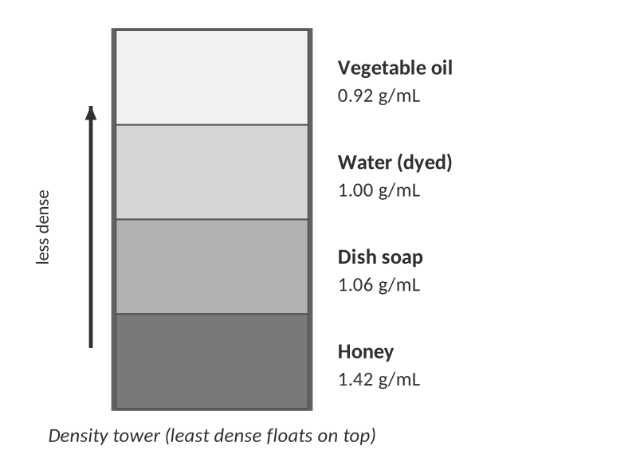
1. Why do the liquids stack in this order? Use the word density in your explanation.
The least dense liquid (vegetable oil, 0.92 g/mL) floats on top and the most dense (honey, 1.42 g/mL) sinks to the bottom. A denser fluid has more mass in the same volume, so gravity pulls it lower.

2. A plastic bead with a density of 1.03 g/mL is dropped into the tower. Between which two layers will it come to rest? Explain.
Between the water (1.00 g/mL) and the dish soap (1.06 g/mL). It sinks in oil and water (it is denser than both) but floats on the soap (it is less dense than the soap).

LAB CORNER • Finding the density of a metal by displacement

A student masses an unknown metal sample, then lowers it into a graduated cylinder of water.
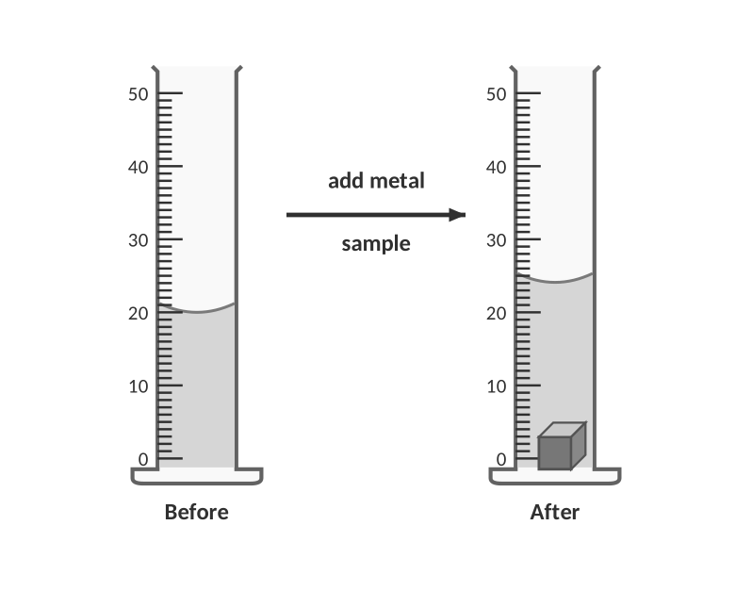
DATA
Mass of metal sample = 32.3 g. Water level before = 20.0 mL. Water level after = 24.1 mL.

3. Use the data above to analyze the metal sample.
a. Volume of the metal:
V = 24.1 mL − 20.0 mL = 4.1 mL = 4.1 cm³

Answer (units & sig figs): 4.1 cm³
b. Density:
d = m / V = 32.3 g / 4.1 cm³ = 7.878… g/cm³ (2 s.f., from 4.1)

Answer (units & sig figs): 7.9 g/cm³
4. Identify the metal.
Iron (7.87 g/cm³ is the closest match).

Substance | Density (g/cm³ or g/mL) | Substance | Density (g/cm³ or g/mL)
Magnesium | 1.74 | Zinc | 7.14
Aluminum | 2.70 | Iron | 7.87
Titanium | 4.51 | Copper | 8.96
Water (4 °C) | 1.00 | Lead | 11.34
Ethanol | 0.789 | Gold | 19.3
Ice (0 °C) | 0.917 | Mercury | 13.53

WATCH OUT!
The density of a block of aluminum does not depend on how big it is. A big block has a larger mass AND a larger volume — the ratio stays 2.70 g/cm³.

WORKED EXAMPLE — REGULAR SOLID
A rectangular block measures 3.00 cm × 2.50 cm × 4.20 cm and has a mass of 85.1 g. What is its density, and what metal could it be?

V = 3.00 × 2.50 × 4.20 = 31.5 cm³
d = 85.1 g / 31.5 cm³ = 2.701… g/cm³ → 2.70 g/cm³ (aluminum)

Answer: 2.70 g/cm³ (aluminum)
WORKED EXAMPLE — LIQUID WITH A GRADUATED CYLINDER
An empty graduated cylinder has a mass of 45.30 g. With 20.0 mL of an unknown liquid it has a mass of 61.10 g. What is the density?

mass of liquid = 61.10 − 45.30 = 15.80 g
d = 15.80 g / 20.0 mL = 0.790 g/mL (ethanol)

Answer: 0.790 g/mL
Practice
5. Two blocks of pure copper are weighed: block A is 400 g and block B is 25 g. A student predicts block A has a higher density because it is heavier. Is the student right? Explain.
No. Density is an intensive property, so both blocks have the same density (8.96 g/cm³). Block A has a larger mass but also a proportionally larger volume.

6. A gold bar has a mass of 1.00 kg. The density of gold is 19.3 g/cm³. What volume (in cm³) does the bar occupy?
1.00 kg × (1000 g / 1 kg) = 1000. g; V = m/d = 1000. g / 19.3 g/cm³ = 51.81… cm³

Answer (units & sig figs): 51.8 cm³
7. A sample of mercury (d = 13.53 g/mL) fills a 25.0 mL cylinder to the top. What is the mass of the mercury in grams?
m = d × V = 13.53 g/mL × 25.0 mL = 338.25 g

Answer (units & sig figs): 338 g
8. A 62.5 g metal sample is lowered into a cylinder that reads 32.0 mL. The water level rises to 39.0 mL. Calculate the density and identify the metal.
V = 39.0 − 32.0 = 7.0 mL; d = 62.5 g / 7.0 mL = 8.93 g/mL (2 s.f.) → copper (8.96 g/cm³)

Answer (units & sig figs): 8.9 g/mL (copper)
9. Ice has a density of 0.917 g/cm³ and liquid water 1.00 g/cm³. What fraction of a floating ice cube is below the waterline? Explain in terms of density.
About 91.7%. A floating object sinks until the weight of water it displaces equals its own weight, so the fraction submerged = d(object)/d(fluid) = 0.917/1.00. Ice floats because it is less dense than liquid water — water is unusual because its solid is less dense than its liquid (hydrogen bonding forms an open lattice).

10. A can of regular soda sinks in water but a can of diet soda floats. Both cans have the same size and the same amount of liquid. Explain.
The regular soda contains a large mass of dissolved sucrose (about 39 g per can) while diet soda contains only a tiny mass of sweetener. Same volume, more mass → higher density. Regular soda is denser than water and sinks; diet soda is less dense and floats.

LAB CORNER • Design a lab

You are given a rubber stopper that floats and is too wide to fit into a graduated cylinder.
11. Describe a procedure (with the tools you would use) to measure the density of the stopper. Include how you would handle the fact that it floats.
1. Measure the stopper's mass on a balance.
2. Find its volume by displacement: fill an overflow can (or a large beaker placed in a tray) to the brim, push the stopper fully under water with a pin/thin wire, and collect the displaced water in a graduated cylinder; that volume is the stopper's volume. (Or tie a small sinker to it and measure the volume change with sinker alone and sinker + stopper.)
3. Calculate d = mass / volume. Repeat at least three times and compare to an accepted value with % error.

TEACHER NOTE
Sink/float demos worth doing: Coke vs Diet Coke in a tank of water; an egg in fresh vs. salt water; a density tower with colored layers (honey, dish soap, water, vegetable oil, 2-propanol). Safety: use food-safe materials, goggles on.

PRACTICE
Extra Practice — Unit 0
Work these on your own or with a partner. Show all work.

A. Reading scales
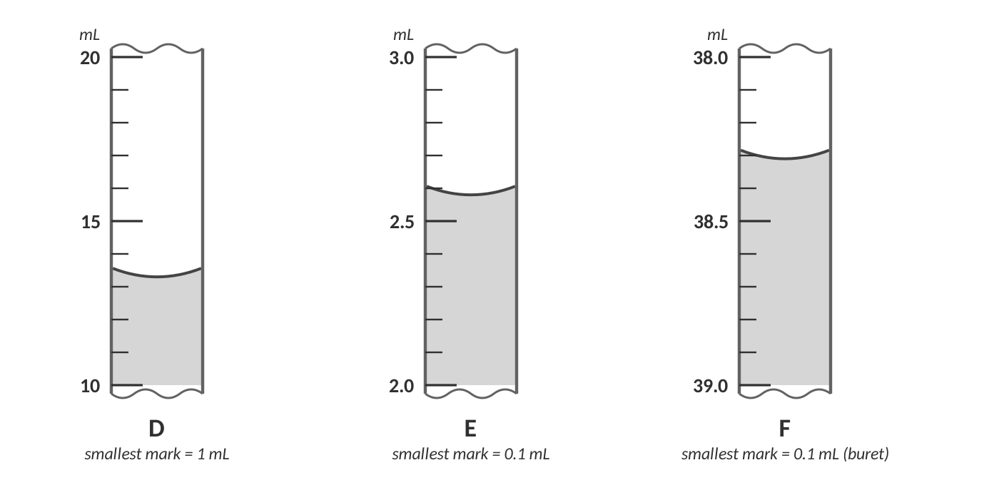
Scale readings D, E and F. Buret F reads downward.
 | Smallest mark | Reading with unit | Estimated digit is in the… place | # sig figs
D | 1 mL | 13.3 mL | tenths | 3
E | 0.1 mL | 2.58 mL | hundredths | 3
F (buret) | 0.1 mL | 38.31 mL | hundredths | 4

TEACHER NOTE
Accept D: 13.2–13.4; E: 2.57–2.59; F: 38.30–38.32.

1. A student must add exactly 25.00 mL of acid to a flask. Which tool should she choose, a 50 mL beaker or a buret? Explain using the idea of the estimated digit.
A buret. Its smallest marks are 0.1 mL, so she can estimate to the hundredths place and report 25.00 mL (4 sig figs). A beaker's rough marks (about ±10%) can't support that precision.

B. Significant figures
Number | # sig figs | Number | # sig figs
0.0070 | 2 | 7.0 × 10⁻³ | 2
2,040 | 3 | 2,040. | 4
0.5000 | 4 | 300 | 1
3.00 × 10² | 3 | 1,004,000 | 4
0.020300 | 5 | 60. | 2

Round to… | 63,849 | 0.008752 | 2.4850
3 s.f. | 6.38 × 10⁴ | 8.75 × 10⁻³ | 2.49
2 s.f. | 6.4 × 10⁴ | 8.8 × 10⁻³ | 2.5

2. Write 4,500,000 in scientific notation (a) with 2 sig figs and (b) with 4 sig figs.
(a) 4.5 × 10⁶ (b) 4.500 × 10⁶

3. Explain why 0.0050 g and 0.005 g are NOT the same measurement even though they look like the same amount.
0.0050 g has 2 sig figs (balance good to 0.0001 g) while 0.005 g has only 1 (good to 0.001 g). The extra zero is a significant, measured digit that tells you the balance was more precise.

C. Calculations with sig figs
Problem | Answer with correct sig figs
14.56 g + 3.2 g + 0.003 g | 17.8 g
100.0 mL − 37.45 mL | 62.6 mL
4.00 cm × 2.50 cm × 1.0 cm | 10 cm³
88.0 g ÷ 12.011 | 7.33
(12.5 + 0.75) × 2.00 | 26.5
(3.0 × 10⁴) × (2.50 × 10⁻²) | 7.5 × 10²
0.00560 ÷ 0.0200 | 0.280
12 eggs × 58.4 g per egg (12 is exact) | 701 g

D. Dimensional analysis
4. A swimming pool holds 2.50 × 10⁴ gallons. How many liters is that? (1 gal = 3.79 L)
Set up the chain of conversion factors so every unwanted unit cancels.

Answer (units & sig figs): 9.48 × 10⁴ L
5. A runner covers 5.00 km in 22.5 min. What is the speed in m/s?
Set up the chain of conversion factors so every unwanted unit cancels.

Answer (units & sig figs): 3.70 m/s
6. How many seconds are in a 365-day year? (Treat 365 as exact.)
Set up the chain of conversion factors so every unwanted unit cancels.

Answer (units & sig figs): 3.15 × 10⁷ s
7. A drop of water is 0.050 mL. How many drops are in 1.00 L?
Set up the chain of conversion factors so every unwanted unit cancels.

Answer (units & sig figs): 2.0 × 10⁴ drops
8. The speed of light is 3.00 × 10⁸ m/s. Express this in mi/h. (1 mi = 1609 m)
Set up the chain of conversion factors so every unwanted unit cancels.

Answer (units & sig figs): 6.71 × 10⁸ mi/h
9. A room has a volume of 45.0 m³. What is the volume in liters? (1 m³ = 1000 L)
Set up the chain of conversion factors so every unwanted unit cancels.

Answer (units & sig figs): 4.50 × 10⁴ L
E. Density
10. A cube of an unknown metal is 2.00 cm on each side and has a mass of 21.6 g. Calculate the density. Is the metal aluminum (2.70 g/cm³), zinc (7.14 g/cm³) or iron (7.87 g/cm³)?
V = (2.00 cm)³ = 8.00 cm³; d = 21.6 g / 8.00 cm³ = 2.70 g/cm³ → aluminum

Answer (units & sig figs): 2.70 g/cm³ (aluminum)
11. The density of ethanol is 0.789 g/mL. What volume of ethanol has a mass of 50.0 g?
V = m/d = 50.0 g / 0.789 g/mL = 63.37… mL

Answer (units & sig figs): 63.4 mL
12. A piece of lead (d = 11.34 g/cm³) has a volume of 3.5 cm³. What is its mass?
m = d × V = 11.34 × 3.5 = 39.69 g (2 s.f.)

Answer (units & sig figs): 40 g
13. A student drops a solid into a cylinder and the level rises from 18.0 mL to 25.0 mL. The solid has a mass of 40.6 g. She reports its density as 5.8 g/mL. Another student says the density should be 5.80 g/mL. Who is right and why?
V = 7.0 mL (2 s.f., from 25.0 − 18.0 = 7.0). d = 40.6/7.0 = 5.8 g/mL. The first student is right: the volume has only 2 sig figs, so the density is limited to 2 sig figs.

F. Lab data analysis
THE EXPERIMENT
A student finds the density of an unknown liquid three times, using different amounts. She uses a balance (±0.01 g) and a graduated cylinder. The accepted density of ethanol is 0.789 g/mL.

Trial | Mass of liquid (g) | Volume (mL) | Density (g/mL)
1 | 19.82 | 25.0 | 0.793
2 | 15.91 | 20.0 | 0.796
3 | 8.06 | 10.0 | 0.806

14. Calculate the average density and the percent error compared with the accepted value for ethanol.
Average = (0.793 + 0.796 + 0.806) ÷ 3 = 0.798 g/mL
% error = |0.798 − 0.789| ÷ 0.789 × 100 = 1.2 %

Average density / % error: 0.798 g/mL; 1.2 %
15. Are the three trials precise? Are they accurate? Explain.
Reasonably precise (0.793–0.806, close together). Reasonably accurate (the average is within about 1–2% of 0.789). Trial 3 is a little high — its small volume means a bigger relative uncertainty in reading the cylinder.

16. Name one source of random error and one source of systematic error in this experiment, and how each would affect the results.
Random: variation in reading the meniscus. It spreads the results above and below the true value (hurts precision). Systematic: the balance not being zeroed, or evaporation of ethanol before massing — it pushes all results the same way (hurts accuracy).

[ IMAGE GOES HERE ]
Optional: a photo of your lab station (balance, graduated cylinders, unknown liquids) or an AP-style lab diagram

G. Error analysis — find the mistake
17. A student converts 5.0 miles to feet like this: 5.0 mi × (1 mi / 5280 ft) = 0.00095 ft. What went wrong? Write the correct setup and answer.
The conversion factor is upside down, so the mi did not cancel. Correct: 5.0 mi × (5280 ft / 1 mi) = 26,400 ft → 2.6 × 10⁴ ft (2 s.f.).

18. A student measures a mass of 56.7 g and a volume of 5.0 mL and reports the density as 11.3400 g/mL. Give two things wrong with this answer and the correct result.
(1) It has far too many sig figs; the volume has only 2 s.f., so the answer must have 2 s.f. (2) The unit is fine, but the value should be 11 g/mL (56.7/5.0 = 11.34).

TOPIC  ★ | Unit 0 Review  Put it in your own words before the test

1. In two or three sentences, explain what significant figures tell someone who reads your data.
They show how precisely each measurement was made: all the certain digits plus one estimated digit. Reporting more digits than the tool could measure claims accuracy that you don't have.

2. Explain the difference between the rules for adding and multiplying measurements. Give a one-line example of each.
Adding/subtracting: round to the fewest DECIMAL PLACES (12.11 + 18.0 = 30.1). Multiplying/dividing: round to the fewest SIG FIGS (6.38 × 2.0 = 13).

3. Describe the steps of dimensional analysis as if you were explaining it to a friend who missed class.
Start with what you were given (number and unit). Multiply by fractions made from known equalities, each arranged so the unit you don't want sits on the opposite side and cancels. When only the wanted unit is left, calculate and round to the sig figs of the measured quantity.

4. Why is density called an identifying property of a substance, but mass is not?
Density is intensive: it stays the same regardless of sample size, so it is characteristic of the substance. Mass depends on how much you have.

5. Draw and label a quick sketch showing how to read the volume in a graduated cylinder. Include the meniscus, eye level and which digit is estimated.
Sketch: cylinder with curved meniscus, eye at the same height as the bottom of the curve, mark = reading with the last digit estimated between the smallest marks.

Sources & further reading
• SERC / Carleton – significant figures vignette (found in research; not reviewed in full) — https://serc.carleton.edu/eddie/teaching_materials/vignettes/significant_figures.html
• Frostburg State – simple sig fig rules (Senese) — https://antoine.frostburg.edu/chem/senese/101/measurement/faq/simple-sigfig-rules.shtml
• ACS Middle School Chemistry – density lesson — https://acs.org/middleschoolchemistry/lessonplans/chapter3/lesson5.html
• ACS Inquiry in Action – density of liquids — https://www.acs.org/education/resources/k-8/inquiryinaction/fifth-grade/substances-have-characteristic-properties/density-of-liquids.html
• NSTA Science Scope – disequilibrium layered liquids — https://www.nsta.org/science-scope/science-scope-aprilmay-2017/disequilibrium-layered-liquids
• LibreTexts – Measurement uncertainty, accuracy and precision — https://chem.libretexts.org/Courses/Lumen_Learning/Book%3A_General_Chemistry__Lecture_and_Lab_(Lumen)/01%3A_Essential_Ideas/1.10%3A_Measurement_Uncertainty_Accuracy_and_Precision
• LibreTexts – Dimensional analysis — https://chem.libretexts.org/Courses/Anoka-Ramsey_Community_College/Introduction_to_Chemistry/02:_Measurements/2.06:_Dimensional_Analysis
• ChemEd X – A critical look at units (MOLE-O game, units activities) — https://chemedx.org/taxonomy/term/1912

